March 11, 2020

Dear ACEC Member,

Last month ACEC’s Board of Directors approved the 2020 rules & regulations and rates.

New for the 2020 Irrigation Season:

- NO RATE INCREASE!!!
- All projects costs are based on a time & material basis starting in 2020
- Inspections are required on all new services or services that have had work performed on them

Facility Charges

Please indicate how you wish to be billed the $1,440 annual facility charge for each well: $120.00 for 12-month or $240 for 6-month billing (April through September 2020). If you have leases expiring or other situations where you know a well will be going to a different operator next season, I encourage you to use the 6-month facility charge for at least that well. This alleviates confusion when property leases end on the calendar year, and irrigation bills run on a fiscal year of April through March.

2020 Control Periods and Rates

All energy is $0.04/kWh, demand rates are listed below.

OP – Off Peak
Potential to control from 8 a.m. to 8 p.m., Monday through Friday
$10.70 per KW of Maximum Demand

No Control- No control period
$36.83 per KW of Maximum Demand

Once again in 2020, **Demand will be billed for every month demand is incurred**ACEC is billed for demand through our power supplier every month. All demand cost incurred but not billed to irrigation from October 1 – March 31 was ultimately paid by the rest of the membership. When you are done irrigating for the season you are encouraged to turn your main disconnect off. Electronics and DC transformers may consume energy and create a small demand, even in months of no activity.

**DUE TO THE HIGH VOLUME OF WELLS CHANGING CONTROL STRATEGY THROUGHOUT THE SEASON, MOVING FROM CONTROL TO NO CONTROL OR VICE-VERSA WILL REQUIRE 24 - HOUR ADVANCE NOTIFICATION**

ACEC’s Demarcation for Irrigation Services

ACEC’s demarcation point of transferring service from utility to member has historically been the service disconnect for irrigation services, meaning ACEC provided all wire and facilities up to the service disconnect. Wisconsin Electrical Statute has changed, requiring our facilities to end at the meter socket, and for a licensed electrician to terminate in the member’s panel. This change also allows for greater flexibility in placing ACEC facilities, or member provided secondary wire to the pump. On any new services the member will furnish the meter socket, which must be located within 25 feet of a fused main disconnect.

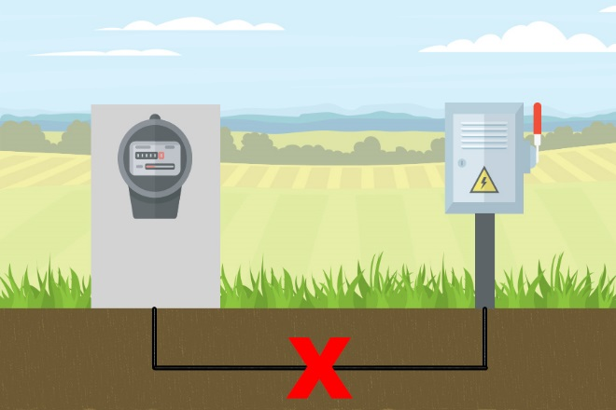

Before calling in an outage, check your facilities. If it is realized the problem is after the meter, please call in for a disconnect/reconnect for you to work safely on your equipment. If you have a power outage, your meter will be blank.

Load Control Notification

ACEC will once again be texting out load control times. Accompanying this letter are instructions on how to sign up for text notifications via SmartHub, instructions are also available on our website. ACEC does offer load control information on our website home page at www.acecwi.com as well. Load control notifications will only be texted April – November.

Field/Contact Information

If you are operating a well this year, accompanying this letter is your 2020 Rate/Control Period request form. To make changes on the form, please write the new control period inside the box. All wells will default to Off Peak control for the start of the season, unless you specify differently. In the column labeled, GPM, you can write in the gallons per minute your well pumps and I can include your water pumping data in the well reports at the end of the season. If you refer to a field by a name and it is not listed or correct, please add it to the form. Also, please strike the entire line if you will not have a well for this season and write the name of the new operator if known.

It is very important to get this information back in a timely fashion. This is the only way ACEC knows who is operating irrigation wells. Please return this form by April 13th, 2020 in the envelope provided.

If you have any questions, please contact me at (608) 339-5428 or at jhuhnstock@acecwi.com

Have a Safe Growing Season,

Jeremy Huhnstock
Key Accounts Coordinator

