January 25, 2018

Dear Grower,

Last month ACEC’s Board of Directors approved a series of changes for the 2018 irrigation season. The rate changes outlined below will be effective starting April 1st, 2018, and strive to align irrigation related charges more closely with other rate classes and ACEC installation practices.

Changes for the 2018 Irrigation Season:

- Demand will be billed every month that a demand is created on the meter. Past practice was demand billed only April – September

- Monthly Facility charge will go up $10/month as outlined over the past two seasons

- Energy (kWh) charges will increase $0.002 to $0.04/kwh; demand (KW) will increase $1 per KW

- The Power Cost Adjustment (PCA) base was separated and lowered, which will lower energy costs, despite the modest increase above

- ACEC’s demarcation point will be our meter, not the service disconnect Details follow.

- New service installations will see a higher base fee (mobilization cost) but a lower cost calculation on a per foot basis.

- ACEC will contribute up to a maximum $3,000 per installation, based on 25% of the project for 3-phase and 35% for 1-phase in 2018. The changes in line extension fees and policy was effective January 22, 2018. NOTE: This ACEC contribution will be phased out after the 2018 construction season.

Facility Charges

Please indicate how you wish to be billed the $1,440 annual facility charge for each well; @ $120.00 for 12-month or $240 for 6-month billing (April through September 2018). If you have leases expiring or other situations where you know a well will be going to a different operator next season, I encourage you to use the 6 month facility charge for at least that well. This alleviates confusion when property leases end on the calendar year, and irrigation bills run on a fiscal year of April through March.

Control Periods and Rates

All energy is $0.04/kWh, demand rates are listed below.

OP – Off Peak
Potential to control from 8 a.m. to 8 p.m., Monday through Friday
$10.70 per KW of Maximum Demand

No Control- No control period
$35.00 per KW of Maximum Demand

**Demand will be billed for every month demand is incurred**ACEC is billed for demand through our power supplier every month. All demand cost incurred but not billed to irrigation from October 1 – March 31 was ultimately paid by the rest of the membership. When you are done irrigating for the season you are encouraged to throw your main disconnect. Electronics and DC transformers may consume energy and create a small demand, even in months of no activity.

**DUE TO THE HIGH VOLUME OF WELLS CHANGING CONTROL STRATEGY THROUGHOUT THE SEASON, MOVING FROM CONTROL TO NO CONTROL OR VICE-VERSA WILL REQUIRE 24 - HOUR ADVANCE NOTIFICATION**

New Irrigation Service Line Extension Fees/Credits

New irrigation services mobilization fee has increased to help minimize long run projects subsidizing the costs of shorter run projects. The cost per foot of wire dropped for 3-phase from $13 and 1-phase from $6.

3-Phase: $4,300 + $11/foot of wire
1-Phase: $2,700 + $5/foot of wire

Line extension credit will be up to $3,000 or based on 25% of the project for 3-phase and 35% for 1-phase for 2018. The irrigation line extension credit will be gone in 2019.

ACEC’s Demarcation for Irrigation Services

ACEC’s demarcation (point of transferring service from utility to consumer) has historically been the service disconnect for irrigation services, meaning ACEC provided all wire and facilities up to the service disconnect. Wisconsin Electrical Statue has changed, requiring our facilities to end at the meter socket, and for a licensed electrician to terminate in the member’s panel. This change also allows for greater flexibility in placing ACEC facilities, or member provided secondary wire to the pump. ACEC will still furnish the meter socket, which must be located within 25 feet of a fused main disconnect.

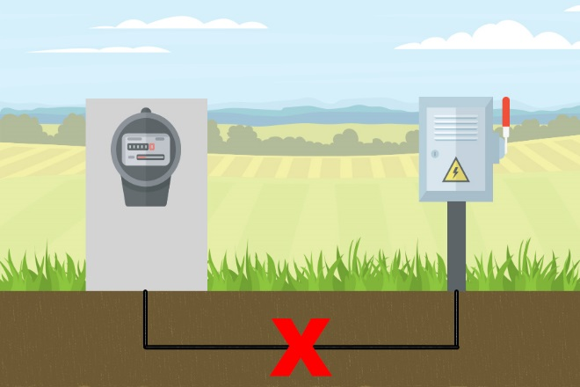

Load Control Notification

ACEC is going to use a new way to notify irrigators of when we will be controlling load. A software called Messenger will allow us to launch texts more reliably using a computer. It is imperative that ACEC receives contact information back for every person your operation wants notified about load control. ACEC does offer load control information on our website front page at www.acecwi.com as well.

Field/Contact Information

Accompanying this letter is your 2018 Rate/Control Period request form. To make changes on the form, please write the new control period inside the box. All wells will default to Off Peak control for the start of the season, unless you specify differently. In the column labeled GPM you can write in the gallons per minute your well pumps and I can include your water pumping data in the well reports at the end of the season. If you refer to a field by a name and it is not listed or correct, please add it to the form. Also, please strike the entire line if you will not have a well for this season, and write the name of the new operator if known.

In the following weeks a letter will be sent out for irrigation meetings happening in each of our service areas.

It is very important to get this information back in a timely fashion. This is the only way ACEC knows who is operating irrigation wells. Please return this form by March 26, 2018 in the envelope provided or by fax to 608-339-7756.

If you have any questions, please contact me at (608) 339-5428 or at jhuhnstock@acecwi.com.

Cooperatively yours,

Jeremy Huhnstock
Key Accounts Coordinator

